## Title of the Paper (Police 14; Times New Roman)

Author(s): First Author¹, Second Author², … (Police 11; Times New Roman)

Affiliation(s):  
¹ Department, Institution, City, Country  
² Department, Institution, City, Country

Email: corresponding.author@email.com

## Abstract

(Insert your abstract here. The abstract should clearly state the purpose of the study, the methods used, the studied phenomenon, key results obtained, and main conclusions). The abstract should not extend 15 lines.

## Keywords:

(3–5 keywords separated by commas)

## Figure:

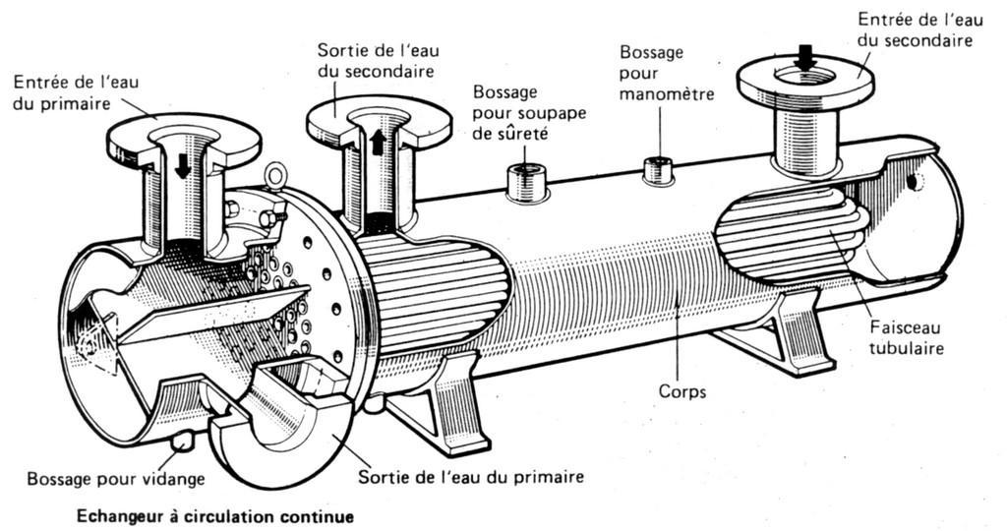

Figure 1: Representation of the studied phenomenon – include a clear, labeled diagram below.